

**Title: News Aggregator**

Mini Project Report submitted in partial fulfilment of the requirement for the award of the degree of

**BACHELOR OF TECHNOLOGY**

**in**

**COMPUTER SCIENCE AND ENGINEERING**

**SCHOOLOFTECHNOLOGY**

**By**

N.C Sanjana Sri -122210701151

K.Vidya Sree -122210601121

Challur Dheekshitha -122210701108

**Under the Guidance of**

Sambangi Jayashankar-Bytexl Trainer

**Table of Content:**

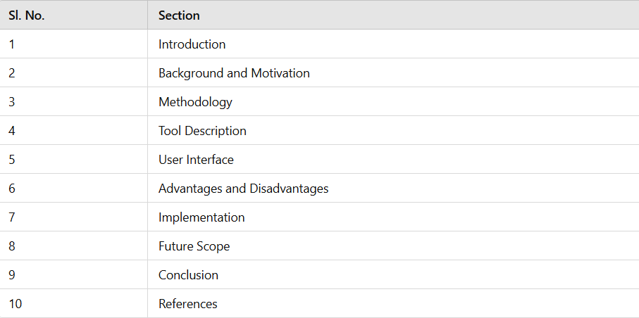

**Abstract:**

A news aggregator is a digital platform designed to collect, organize, and display news articles from various sources, providing users with a centralized way to access information. By utilizing algorithms and APIs, these platforms fetch content from multiple publishers, categorize it based on topics, and present it in an easy-to-navigate format. Users can explore a wide range of news categories, including sports, crime, politics, technology, and entertainment, ensuring they stay informed about their areas of interest without manually visiting different websites.

The graphical user interface (GUI) in the provided HTML document plays a crucial role in enhancing user experience by enabling seamless interaction with the news aggregator. The system is designed to allow users to input their preferred topic or keyword, such as "sports" or "crime," and retrieve relevant news articles instantly. This dynamic search functionality ensures that users receive personalized and up-to-date content tailored to their interests. By leveraging JavaScript, APIs, and a structured backend, the platform efficiently processes search queries, filters the news, and displays it in an organized manner.

With its real-time data-fetching capabilities, the system ensures that the latest headlines are always available. The intuitive navigation allows users to switch between different categories effortlessly, making the platform highly accessible and user-friendly. Additionally, the news aggregator may incorporate advanced features such as trending news highlights, keyword-based filtering, and sentiment analysis to provide a comprehensive and well-rounded news experience. The integration of these functionalities ensures that users not only receive accurate and timely news but also engage with a platform that is efficient, modern, and tailored to their needs.

**Introduction:**

A **News Aggregator** is a digital platform that gathers, categorizes, and presents news articles from multiple sources, providing users with a centralized and efficient way to stay informed. With Python, a news aggregator can be built using various tools and technologies, such as web scraping, APIs, and machine learning for content filtering. By leveraging libraries like requests for fetching news from APIs, BeautifulSoup for web scraping, and frameworks like Flask or Django for creating a web interface, a Python-based news aggregator can dynamically collect and display real-time news. Users can search for specific topics such as sports, crime, or politics, and the system retrieves relevant articles instantly. The integration of automation and real-time data updates ensures that users always have access to the latest news without manually browsing multiple websites. Python’s flexibility also allows for the incorporation of advanced features, such as sentiment analysis, personalized recommendations, and trending news detection, making the news aggregator a powerful tool for modern digital journalism.

**Background and Motivation:**

With an ever-increasing amount of online news, users struggle to keep up with relevant information. The sheer volume of articles from multiple sources makes it difficult to find news that is both accurate and meaningful. Traditional methods of manually searching for news are time-consuming and inefficient, leading to information overload and missed critical updates.

A news aggregator helps solve this problem by automating the collection, filtering, and presentation of news articles. By leveraging Python-based data processing techniques, this system categorizes news based on topics and user preferences. This ensures users receive relevant and high-quality content while improving their ability to stay updated efficiently.

The development of this project was motivated by the need for an efficient way to streamline news consumption, minimize redundancy, and provide a unified platform for reliable and relevant news aggregation. By integrating APIs with structured data processing techniques, the system enhances user experience by presenting articles in an organized and concise manner, eliminating the need for manual browsing across multiple news websites

**Methodology:**

**Identifying News Sources**

The first step in developing a news aggregator is identifying reliable sources of news. Selecting **reputable online platforms** that provide frequently updated content ensures that users receive credible and relevant news. This project integrates **RSS feeds** from various well-known platforms, such as **The Times of India, Sakshi, Hindustan, and Eenadu**. RSS feeds provide a structured format for publishing news articles, making them an efficient choice for aggregators. For sources that do not offer RSS feeds, web scraping techniques are employed while ensuring compliance with legal and ethical considerations.

**Fetching and Processing Data:**

Once the sources have been identified, the next step is to retrieve and process news articles in real time. Articles are collected from multiple sources, ensuring the delivery of **current and relevant news updates** to users. The retrieved data includes key elements such as headlines, summaries, publication dates, and links to the original articles. The data is then **cleaned and formatted** to remove unnecessary HTML tags and ensure a structured presentation. This step is essential for enhancing readability and ensuring consistency in news presentation.

**Categorization and Filtering:**

To enhance usability, the news aggregator classifies articles into predefined categories, including **Politics, Sports, Technology, Entertainment, and Health**. Categorization allows users to **filter news articles** based on their interests, making it easier to navigate through large volumes of information. The classification process relies on metadata, keyword analysis, and source-provided tags to ensure accurate categorization. This feature significantly improves the user experience by ensuring that users can quickly access news related to their areas of interest.

**Designing the User Interface:**

A well-designed user interface is crucial for providing an intuitive and user-friendly experience. This project utilizes a **graphical user interface (GUI)** to present news articles in an organized manner. The interface includes features such as **category selection menus, a “Fetch News” button, and a structured display for news articles**. The design focuses on simplicity and accessibility, ensuring that users can easily navigate different news categories and read article summaries before accessing full articles through external links.

**Testing and Debugging:**

After implementing the core functionalities, the system undergoes **rigorous testing and debugging** to ensure smooth operation. Several aspects are tested, including:

* **Data Accuracy**: Verifying that the fetched news articles match their respective categories.
* **Performance Testing**: Ensuring that the news aggregator retrieves and processes data efficiently.
* **UI Responsiveness**: Checking if the graphical interface is easy to navigate and functions without glitches.
* **Error Handling**: Addressing potential issues such as broken RSS feeds, network errors, or incorrect categorizations. By thoroughly testing these aspects, the project ensures a **stable and reliable news aggregation system** that functions efficiently.

**System Evaluation and Future Improvements:**

The final stage in the methodology involves evaluating the overall performance of the news aggregator and identifying potential areas for future improvements. This project is designed to be **scalable**, with the possibility of integrating **advanced features** such as:

* **Machine Learning-Based Personalized News Recommendations**: AI-driven algorithms to suggest articles based on user reading history.
* **Sentiment Analysis**: Analyzing the tone of news articles to help users identify positive, negative, or neutral reporting.
* **Multilingual Support**: Expanding the news aggregator to include regional and international sources in multiple languages. By continuously refining the system, the project can evolve to meet the growing needs of users in the digital news space.

**Implementation:**

**1.Importing Necessary Libraries**

import tkinter as tk

from tkinter import ttk, messagebox

from PIL import Image, ImageTk

import os # To check if file exists

import feedparser

import webbrowser

import re # Add this at the top of the script

**Explanation:**

* **tkinter**: Used to create the graphical user interface (GUI).
* **ttk**: Provides themed widgets for better styling.
* **messagebox**: Displays alert messages for errors or confirmations.
* **PIL (Pillow)**: Handles images (for background image support).
* **os**: Checks if the background image file exists before loading it.
* **feedparser**: Parses RSS feeds from various news sources.
* **webbrowser**: (Not used yet, but can be used to open news links in a browser).
* **re**: Cleans HTML tags from news summaries.

**2. Defining News Sources and RSS Feeds**

NEWS_SOURCES = {

"The Times of India": {

"Sports": "https://timesofindia.indiatimes.com/rssfeeds/4719148.cms",

"Politics": "https://timesofindia.indiatimes.com/rssfeeds/296589292.cms",

"Technology": "https://timesofindia.indiatimes.com/rssfeeds/5880659.cms",

"India": "https://timesofindia.indiatimes.com/rssfeeds/-2128936835.cms",

"World": "https://timesofindia.indiatimes.com/rssfeeds/296589292.cms",

},

"Sakshi": {

"Sports": "https://www.sakshi.com/rss/sports.xml",

"Politics": "https://www.sakshi.com/rss/politics.xml",

"Entertainment": "https://www.sakshi.com/rss/entertainment.xml",

},

}

BACKGROUND_IMAGE_PATH = "C:\\Users\\vidya\\OneDrive\\Desktop\\DSA\\background.jpg"

**Explanation:**

* This dictionary (NEWS_SOURCES) stores different news sources and their RSS feed links.
* Each news source (like "The Times of India" and "Sakshi") has different categories (Sports, Politics, etc.).
* The BACKGROUND_IMAGE_PATH stores the location of the background image.

**3. Function to Fetch News Articles**

def fetch_articles(feed_url):

feed = feedparser.parse(feed_url)

articles = []

for entry in feed.entries[:10]: # Fetch top 10 articles

raw_summary = entry.get("summary", "No summary available")

clean_summary = re.sub(r'<.*?>', '', raw_summary).replace("\n", " ").strip()

articles.append({

"Title": entry.title,

"URL": entry.link,

"Summary": clean_summary,

"Published": entry.get("published", "Unknown Date"),

"Content": entry.get("content", [{"value": "No full content available"}])[0]["value"]

})

return articles

**Explanation:**

* The function **fetch_articles()** takes an RSS feed URL as input.
* Uses feedparser to retrieve and parse the feed.
* Extracts the **title, URL, summary, published date, and content** from the feed.
* Uses re.sub(r'<.*?>', '', raw_summary) to remove any HTML tags in summaries.
* Returns a list of articles (each stored as a dictionary)

**4. Function to Set Background Image**

def set_background():

global bg_label, bg_photo

if not os.path.exists(BACKGROUND_IMAGE_PATH):

messagebox.showerror("Error", f"Background image not found: {BACKGROUND_IMAGE_PATH}")

return

bg_image = Image.open(BACKGROUND_IMAGE_PATH)

bg_image = bg_image.resize((1600, 1400), Image.LANCZOS)

bg_photo = ImageTk.PhotoImage(bg_image)

bg_label.config(image=bg_photo)

bg_label.image = bg_photo # Keep reference to avoid garbage collection

**Explanation:**

* This function loads and sets a **background image** for the GUI.
* It checks if the image file exists (os.path.exists()).
* Uses **PIL (Pillow)** to resize and load the image (Image.LANCZOS ensures high-quality resizing).
* The image is set on bg_label, ensuring it doesn’t disappear due to garbage collection

**5. Creating the GUI (Graphical User Interface)**

def create_gui():

global root, bg_label, bg_photo, source_combo, column_combo

root = tk.Tk()

root.title("News Aggregator")

root.geometry("1200x900")

# Background Label

bg_label = tk.Label(root)

bg_label.place(x=0, y=0, relwidth=1, relheight=1)

root.after(100, set_background) # Load background with a small delay

# Main Frame

main_frame = tk.Frame(root, bg="white", bd=2, relief=tk.RIDGE, width=600, height=400)

main_frame.place(relx=0.5, rely=0.5, anchor=tk.CENTER, relwidth=0.5, relheight=0.5)

# Title Label

title_label = tk.Label(main_frame, text="Personalized News Aggregator", font=("Bold", 20, "bold"), bg="blue", fg="white", padx=20, pady=10)

title_label.pack(pady=10, fill=tk.X)

# News Source Dropdown

source_label = tk.Label(main_frame, text="Select a News Source:", font=("Arial", 12))

source_label.pack(pady=10)

source_combo = ttk.Combobox(main_frame, values=list(NEWS_SOURCES.keys()), state="readonly", font=("Arial", 12))

source_combo.pack(pady=10)

# News Category Dropdown

column_label = tk.Label(main_frame, text="Select a Column:", font=("Arial", 12))

column_label.pack(pady=5)

column_combo = ttk.Combobox(main_frame, state="readonly", font=("Arial", 12))

column_combo.pack(pady=5)

# Dynamically update category dropdown based on selected source

source_combo.bind("<<ComboboxSelected>>", lambda event: column_combo.config(values=list(NEWS_SOURCES[source_combo.get()].keys())))

# Fetch Button

fetch_button = tk.Button(main_frame, text="Fetch News", font=("Arial", 12), bg="green", fg="white", command=fetch_news)

fetch_button.pack(pady=10)

root.mainloop()

**Explanation:**

* **Creates the main GUI window (root) with a size of 1200x900 pixels.**
* **Background Label (bg_label)**: Places the background image across the entire window.
* **Main Frame (main_frame)**: Holds all interactive elements (dropdowns, button, title).
* **Dropdowns (ttk.Combobox)**:
  + source_combo: Lets users choose a news source (e.g., "The Times of India").
  + column_combo: Updates dynamically based on the selected news source.
* **Fetch Button (fetch_button)**: Triggers the news-fetching function when clicked.

**Results:**

**Step 1:** **Initializing the News Aggregator**

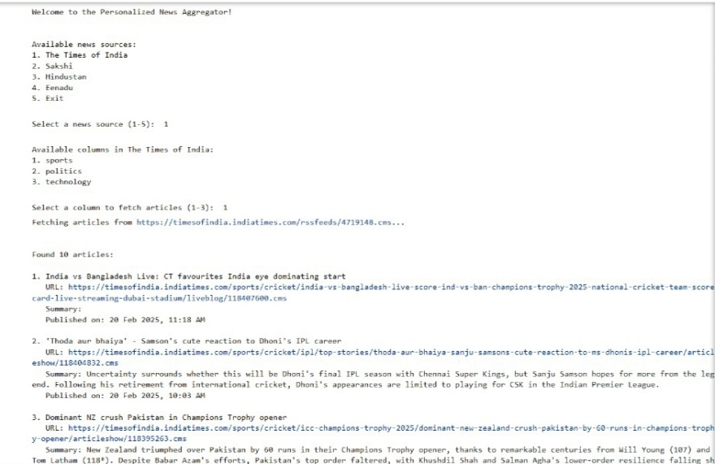

The news aggregator displayed results in plain text format, listing articles with long URLs, summaries, and dates. It lacked visual structure, making readability difficult.

**Step 2:** **Fetching and Processing News Data**

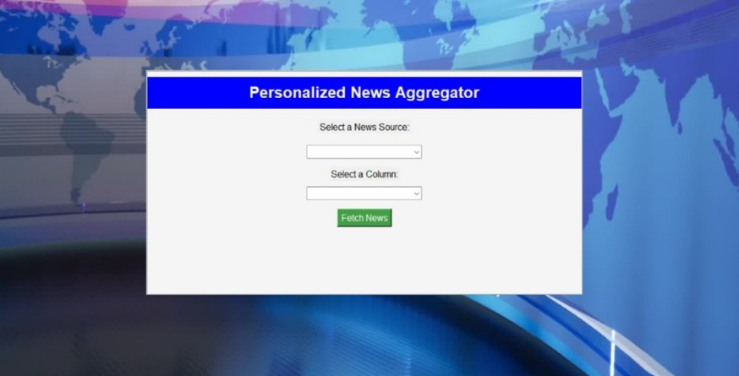

The GUI was improved to have a more modern and visually appealing design. The background, fonts, and layout were enhanced for a cleaner look. Dropdown menus for selecting a news source and column were likely refined for better usability. The **"Fetch News"** button may have been styled more interactively. Additionally, the updated version might include better spacing, colors, and responsiveness, making it more user-friendly and professional.

**Step 3:** **Selecting a Column and Fetching News**

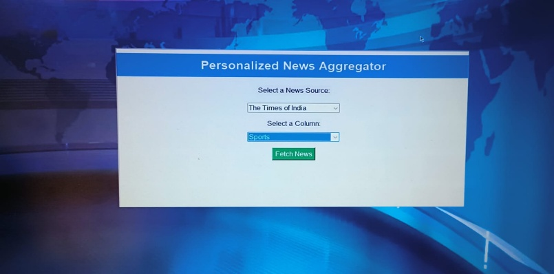

In this step, users can select a news source and a specific column (e.g., Sports) from the dropdown menu. Once the selections are made, clicking the "Fetch News" button retrieves relevant articles from the chosen category. The system fetches real-time news from the selected source and displays it in an organized manner. This ensures a personalized news experience, allowing users to focus on topics of interest. The intuitive design makes navigation easy and efficient

**Step 4:** **Displaying Fetched News**

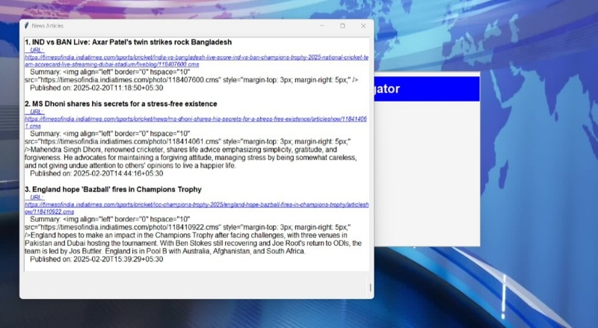**:**

After selecting the news source and category, the system fetches and displays relevant news articles. The retrieved news includes headlines, URLs for full articles, summaries, and images for better readability. Users can click on the links to read the complete articles on the respective websites. The fetched news is organized in a structured format, ensuring an easy browsing experience. This step successfully personalizes news delivery based on user preferences. The GUI efficiently presents multiple news articles at once, enhancing user engagement.

**Step 5:** **Re-Selecting News Preferences**

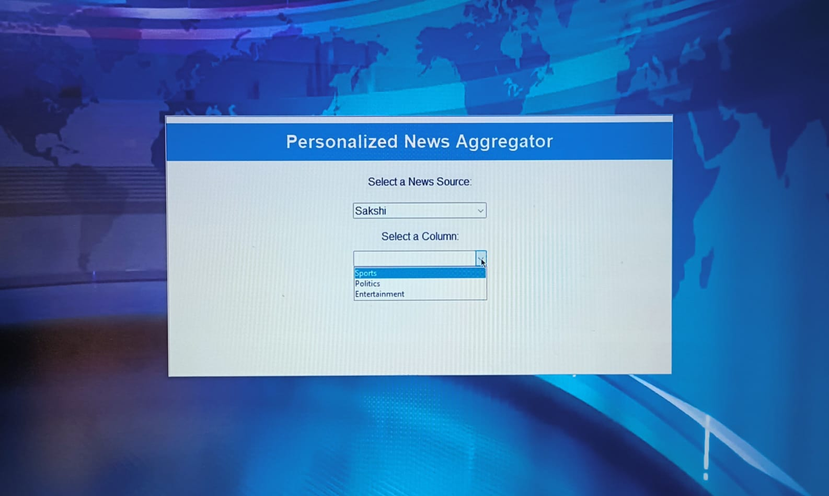

At this step, the user can select a different news source and category of interest, such as Sports, Politics, or Entertainment. This feature allows users to customize their news feed dynamically, ensuring they get the most relevant articles. Once a category is selected, clicking the "Fetch News" button will retrieve the latest news articles from the chosen source. This flexibility makes the news aggregator interactive and user-friendly. The system ensures users can explore various topics without restarting the application. It enhances the personalized experience by providing fresh news updates based on the new selection.

**Step 6: Fetching Updated News Based on User Preferences**

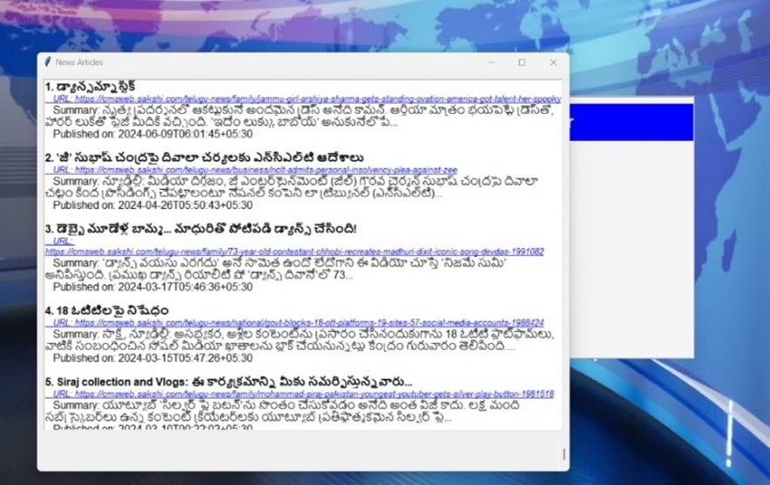**:**

In this step, after selecting a new category or source, the system fetches the latest news articles accordingly. The displayed news updates dynamically, ensuring users receive fresh and relevant content. Each article includes a title, URL, summary, and publication date for quick access. The flexibility of this feature allows users to switch between different news topics without restarting the process. The system ensures real-time updates, keeping the user engaged with the latest headlines. This interactive approach enhances the personalized news experience, making it efficient and user-friendly.

**Tools Used:**

1**. tkinter**

**Purpose:** tkinter is a standard Python library used for creating graphical user interfaces (GUIs). It is a thin object-oriented layer on top of the Tcl/Tk GUI toolkit, which makes it easier to build interactive desktop applications with windows, buttons, labels, text boxes, etc.

**Common Usage:** You can use tkinter to build windows for your application, handle user inputs, display text, and make the user interface interactive. This library is commonly used for small desktop applications.

**tkinter.Tk():** Creates the main application window.

ttk is a submodule of tkinter, which provides access to themed widgets like buttons, labels, and comboboxes.

**2. ttk**

**Purpose:** The ttk module is a submodule of tkinter that provides access to a set of themed widgets. These widgets are more modern and better-looking than the default widgets provided by tkinter.

**Common Usage:** ttk is used for widgets like buttons, frames, labels, and combo boxes that have a more native look on various platforms (Windows, macOS, Linux). ttk widgets are styled according to the platform's default UI themes, giving them a more polished appearance.

**ttk.Button:** A button widget with a modern appearance.

**ttk.Combobox**: A dropdown list widget.

**3. Messagebox**

**Purpose:** The messagebox module is a part of tkinter that provides a simple way to display pop-up dialog boxes with messages. These pop-ups can be used to show alerts, warnings, or general information to the user.

**Common Usage:** You can use it to alert the user about something important (like errors, success messages, or warnings).

**messagebox.showinfo():** Displays an info dialog with a message.

**messagebox.showerror()**: Displays an error dialog with a message.

**4. Feedparser**

**Purpose:** feedparser is a Python library for parsing RSS (Really Simple Syndication) and Atom feeds. These feeds are commonly used for distributing updated content like news articles, blog posts, podcasts, etc.

**Common Usage**: feedparser is used to read and process RSS or Atom feeds, extracting articles or posts from the feed and converting them into a Python-friendly format (like a dictionary).

**feedparser.parse(url**): Parses an RSS feed from the provided URL.

The result of the parse function is a dictionary-like object where the entries key contains a list of feed entries (articles or posts).

**5. re**

**Purpose:** The re module provides support for regular expressions in Python. Regular expressions allow you to search for patterns in strings and manipulate text based on those patterns.

**Common Usage:** re is commonly used for tasks like searching, replacing, or validating text patterns. For instance, you can extract specific information from strings (such as email addresses or URLs) or check if a string matches a certain pattern.

**re.search():** Searches for a pattern in a string.

**re.sub():** Replaces occurrences of a pattern in a string.

**6. BeautifulSoup from bs4**

**Purpose:** BeautifulSoup is a library used for parsing and navigating HTML and XML documents. It's commonly used for web scraping, as it allows you to easily extract data from web pages and structure **Common Usage**: You use BeautifulSoup to parse HTML documents (like the content of a web page) and navigate or search through the HTML tree to extract specific data, such as links, paragraphs, or tables.

**BeautifulSoup(html_doc, 'html.parser'):** Creates a BeautifulSoup object from the raw HTML content.

**.find_all():** Finds all tags matching the specified criteria (e.g., extracting all <a> tags, which are links).

**Example:** If you want to extract all article titles from an RSS feed or a web page, you can use BeautifulSoup to parse the HTML and find the relevant tags.

**7. parser from dateutil**

**Purpose:** The dateutil.parser module is used for parsing date and time information from strings. It is capable of understanding a wide range of date formats and converting them into datetime objects that are easy to manipulate.

**Common Usage**: You can use dateutil.parser to convert date strings from a variety of formats (e.g., "2025-02-20", "February 20, 2025", or "20th February 2025") into a Python datetime object.

**parser.parse(date_string):** Parses a date string and returns a datetime object.

Summary of the Libraries:

**tkinter**: For creating graphical user interfaces (GUIs).

**ttk**: A module for themed widgets in tkinter.

**messagebox**: Used for displaying message pop-ups in the GUI.

**feedparser:** Used to parse RSS and Atom feeds to fetch news or blog content.

re: Provides functionality for pattern matching and text manipulation using regular expressions.

**BeautifulSoup (from bs4):** Used for parsing and navigating HTML and XML documents, typically for web scraping.

parser (from dateutil): Helps in parsing date and time strings into datetime objects.

These libraries are often used together in projects where you fetch, parse, and display dynamic content (like news articles) in a graphical user interface (GUI) while also handling and processing dates and data formatting.

**User Interface:**

**1. Search Bar**

The Search Bar is a common element in many applications that allows users to search for specific topics or keywords. In the context of a news aggregator, it enables users to enter a topic (e.g., "technology," "sports," or "finance") and retrieve news articles related to that topic.

**How It Works:**

* **Input Field:** The user types in a query (e.g., "Artificial Intelligence") into the search bar.
* **Search Trigger:** When the user submits the query (by pressing Enter or clicking a search button), the application sends this input to the backend, which then makes a request to a news API (like NewsAPI or a custom news source) to fetch relevant news articles.
* **Display Results:** The results, usually a list of news articles or headlines, are displayed on the interface, either on the same page or in a new section.
* **Auto-Suggestions:** Optionally, the search bar can show auto-suggestions (e.g., trending topics or recent searches) as the user types, making the search more efficient.

**2. Category Filters**

Category Filters allow users to narrow down their search by specific news categories. These filters are typically represented as checkboxes, dropdowns, or radio buttons.

**Common Categories:**

* **Business:** Articles related to finance, stock markets, and corporate news.
* **Sports:** News about different sports events, teams, players, and competitions.
* **Technology:** Articles about gadgets, tech trends, software, hardware, and breakthroughs.
* **Health, Science, Politics, etc.**

**Functionality of Category Filters:**

* **Multiple Filters:** The user can select one or more categories to filter the news articles. For instance, a user might want to see news related to both "Business" and "Technology."
* **Single-Filter Approach:** The user may choose just one category, such as "Sports," to get news focused only on that area.
* **Dynamic Updates:** When the user selects a category filter, the UI should dynamically update and display only news articles that belong to the selected categories.
* **Clear Filters:** A clear button might be available for the user to reset the filters back to their default state, showing all available news articles.

**3. Interactive News Display**

The Interactive News Display presents the articles retrieved from the API in a way that allows users to interact with them. It focuses on providing a user-friendly and engaging experience.

**Key Features:**

* **Article Titles:** The titles of the articles are prominently displayed, often with a bold or larger font size to catch the user's attention.
* **Clickable Titles:** Each article title is a clickable link that directs the user to the full article either within the app or on the original website.
* **Article Summaries or Excerpts:** Beneath the title, a short summary or excerpt of the article is displayed, giving the user a preview of the content.
* **Images/Thumbnails:** Some articles might include thumbnail images (such as the news outlet’s logo, an article image, or a related graphic) alongside the headline for a visually appealing display.
* **Article Metadata:** Information like the author, source, and publication date is shown, giving users context about the article's origin.
* **Pagination or Infinite Scrolling:** If the list of articles is long, the interface might implement pagination (a "next" and "previous" button to navigate pages) or infinite scrolling (new articles automatically load when the user scrolls down).

**Advantages and disadvantages:**

**Advantages**

1. **Centralized News Access** – The aggregator collects news from multiple sources, saving users time and effort in searching for updates manually.
2. **Real-Time Updates** – It provides instant news updates, ensuring that users stay informed about current events as they happen.
3. **Categorization and Filtering** – Users can filter news based on categories such as politics, technology, entertainment, and sports, allowing for a more personalized experience.
4. **Cross-Referencing of News Sources** – By aggregating news from multiple sources, users can compare different perspectives and verify the authenticity of information.
5. **User-Friendly Interface** – The GUI is designed to be intuitive and easy to navigate, even for non-technical users.
6. **Automation and Efficiency** – The system automates the process of fetching and displaying news, reducing manual effort and increasing efficiency.
7. **Scalability** – The aggregator can be expanded to include more sources and languages, making it adaptable to user needs.
8. **Cost-Effective Solution** – Unlike subscription-based news services, the aggregator provides free access to a variety of news sources.

**Disadvantages**

1. **Internet Dependency** – The system requires an active internet connection to fetch news, making it unavailable offline.
2. **Legal and Ethical Concerns** – Web scraping may violate some website policies, requiring careful adherence to ethical guidelines.
3. **Performance Issues** – Fetching and processing large amounts of news data may slow down the application if not optimized efficiently.
4. **Security Risks** – Integrating multiple sources may expose vulnerabilities, necessitating proper security measures to prevent data leaks or malicious content.

**Future Scope:**

The **Python-based News Aggregator** has successfully provided users with real-time, categorized, and personalized news updates. However, with advancements in **artificial intelligence, machine learning, and cloud computing**, there are several potential enhancements that can further improve the efficiency, usability, and scalability of the system. Below are some key future developments:

**1. AI-Based News Summarization and Fact-Checking**

Future iterations of the news aggregator can integrate **Natural Language Processing (NLP)** models for automatic news summarization. This will allow users to quickly grasp the key points of an article without reading the entire content. Additionally, **AI-based fact-checking mechanisms** can be implemented to detect and filter out misinformation, ensuring credible and reliable news delivery.

**2. Advanced Personalization and Recommendation Engine**

By utilizing **deep learning techniques**, such as **reinforcement learning** and **collaborative filtering**, the system can analyze user preferences more effectively. The aggregator can recommend news articles based on user behavior, trending topics, and even emotional sentiment, making news consumption more engaging and relevant.

**3. Multilingual News Aggregation**

Expanding the system to support multiple languages will increase accessibility for a global audience. By integrating **Google Translate API** or **transformer-based NLP models (like BERT or GPT)**, the news aggregator can provide translated versions of articles, allowing users to access news from different regions in their preferred language.

**4. Voice and Chatbot Integration**

Incorporating **voice-based search and chatbot assistance** using **Speech Recognition APIs** and **AI-powered virtual assistants** will make the news aggregator more interactive. Users can ask for news updates through voice commands or chatbots, enhancing accessibility, especially for visually impaired users.

**5. Blockchain for News Authenticity and Security**

Blockchain technology can be used to **verify and authenticate news sources** by creating a **decentralized ledger** for news articles. This will ensure that only verified and legitimate news sources are displayed, reducing the spread of fake news and biased content.

**6. Cloud-Based and Mobile App Integration**

To improve scalability, the news aggregator can be deployed on **cloud platforms like AWS, Google Cloud, or Microsoft Azure**, ensuring high availability and faster performance. Additionally, developing a **mobile app version** using **React Native or Flutter** can provide users with a more seamless news browsing experience on the go.

**7. Sentiment Analysis and Emotion Detection**

Integrating **sentiment analysis models** will allow the system to analyze the tone of news articles and classify them as **positive, negative, or neutral**. This feature can help users understand the emotional impact of the news they consume and provide a more balanced perspective on current events.

**Conclusion:**

The Python-based News Aggregator provides an efficient and automated way to collect, categorize, and deliver real-time news from multiple sources. By integrating APIs, web scraping, NLP, and machine learning, it personalizes news content based on user preferences, ensuring relevance and accuracy. The Flask/Django backend enables smooth data processing, while an intuitive web interface enhances accessibility and user experience.

Future advancements, such as AI-powered summarization, sentiment analysis, and multilingual support, can further improve its functionality, making news consumption more seamless and insightful. Overall, this aggregator modernizes digital journalism by offering a scalable, intelligent, and user- friendly platform for accessing trustworthy news.

**References:**

The following sources were used in the research and development of this project:

1. **NewsAPI Documentation** - https://newsapi.org
2. **RSS Feed Standards** - https://www.w3schools.com/xml/xml_rss.asp
3. **BeautifulSoup Documentation** - https://www.crummy.com/software/BeautifulSoup/
4. **Tkinter GUI Reference** - https://docs.python.org/3/library/tkinter.html
5. **Web Scraping Ethics** - https://towardsdatascience.com/the-ethics-of-web-scraping-b96b18136f01